MITRE D3FEND CAD — Lesson Plan
Classification: UNCLASSIFIED

1. Administrative and metadata

1.1 Lesson title
MITRE D3FEND CAD

1.2 Module length
60 minutes (1 hours)
Schedule slot is 60 minutes. Content-guide ~1.5 hours includes the live Quick Start and mini-build (B01.M30-M32 waived inside B01.M28 / B01.M29).

1.3 Terminal and enabling learning objectives
- TLO-1: At the end of the Counterstrike Operator Course, students will possess the ability to conduct military tactical planning in the context of DCO-RA
- TLO-3: At the end of the Counterstrike Operator Course, students will be able deny adversary ability to accomplish their mission in cyberspace.
- ELO-21: Understanding of how to utilize the MITRE CAD tool to graph the attack and defend models

1.4 Prerequisites
- B01.M23: MITRE D3FEND and ENGAGE

1.5 Nested in-class exercises
These extracted drills stay Moodle student activities. They do not have a separate lesson plan.
- B01.M29 Shadowcat Exploration
- B01.M30 CAD Mini-Build

2. Personnel, range, and environment

2.1 Instructor and cadre
- 1 × instructor (required)
- 0 × range_engineer (not_applicable: Lecture Module; no range engineer required)
- 0 × auditor (not_applicable: Not used by this course)
- 0 × oversight_officer (not_applicable: Not used by this course)

2.2 Materials and resources
Instructor resources and pre-class preparation
- Classroom projector and screen; workstations that can open D3FEND CAD
- Whiteboard for comparable-across-teams answers and mini-build checklist
- Live tab: https://d3fend.mitre.org/cad/; CAD docs, blog, and ontology pages
- Instructor copy of ../../references/node_anatomy.jpg for Slide 10
- Nested briefs for B01.M29 (Shadowcat exploration) and B01.M30 (CAD mini-build)
- Navigator layers and paired D3+EAC option sheets students already produced
Student resources and environment
- Student workstations with https://d3fend.mitre.org/cad/
- Nested student briefs for B01.M29 and B01.M30
- Navigator layer and paired option sheet (keep open)
- Exported CAD JSON
- No additional student kit beyond CAD and the prior-layer products

3. Assessment and evaluation
ELO | Method | Related Module | Criteria
ELO-21 | group activity | B01.M30 | Nested CAD mini-build graphs the Navigator intrusion with typed nodes and edges. Shadowcat exploration in B01.M29 precedes the build.

4. Instructional delivery

4.1 Opening, attention grabber, and motivator

Option 1 (Interactive / Whiteboard / Kinesthetic)
- Say: "CAD is the communication product for the analysis you already completed. The goal is not a pretty picture; it is a typed, evidence-grounded graph another team can understand."
- Do: Sketch one Agent, Attack, Artifact, Condition, and Countermeasure on the board and connect them. Tell teams to keep the Navigator layer and paired option sheet available.
- Ask (Q): What two products do you keep open for CAD?
- Expected Response (A): Steer toward the Navigator layer and the paired D3+EAC option sheet.

Option 2 (Digital Slide / Virtual / Slide Deck)
- Say: "CAD is the communication product for the analysis you already completed. The goal is not a pretty picture; it is a typed, evidence-grounded graph another team can understand."
- Show: The objectives and example graph.
- Do: Have teams keep their Navigator layer and paired option sheet available.
- Ask (Q): What two products do you keep open for CAD?
- Expected Response (A): Steer toward the Navigator layer and the paired D3+EAC option sheet.

4.2 Side-by-side table of instruction
Visual / Slide Asset | Instructional Delivery & Instructor Notes
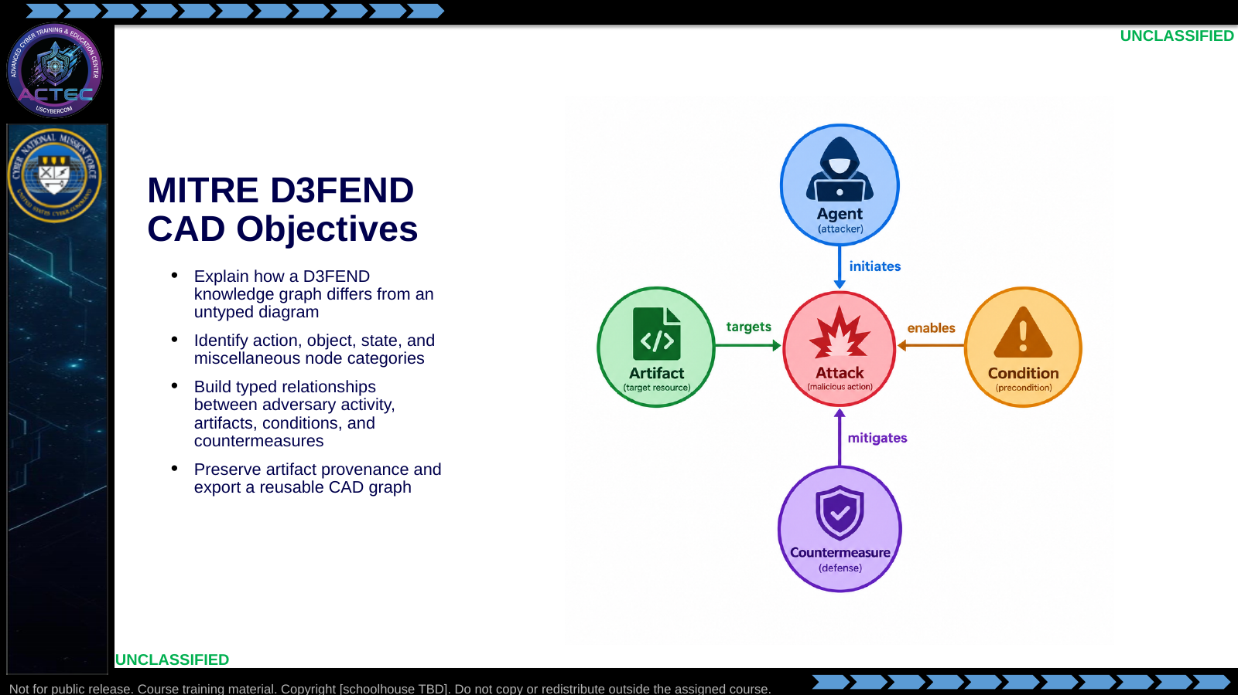  Slide 1: MITRE D3FEND CAD Objectives  Duration: 5 min | Say: "CAD is the communication product for the analysis you already completed. The goal is not a pretty picture; it is a typed, evidence-grounded graph another team can understand."  Show: The objectives and example graph.  Do: Have teams keep their Navigator layer and paired option sheet available.  Ask (Q): What two products do you keep open for CAD?  Expected Response (A): Navigator layer and paired D3+EAC option sheet.
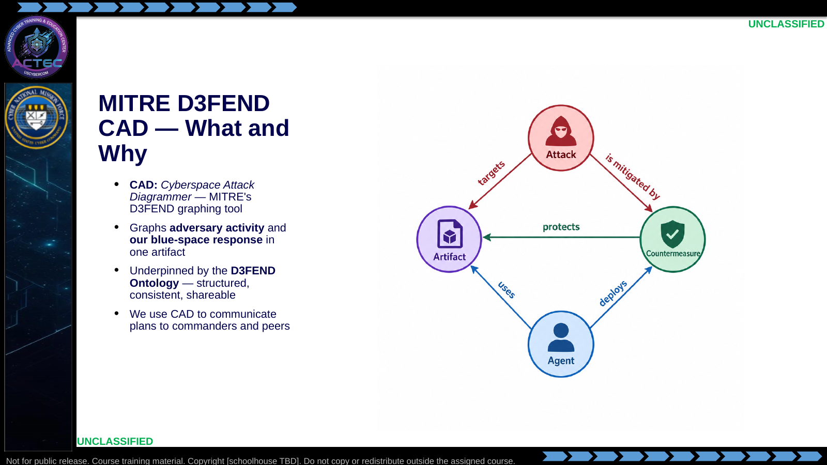  Slide 2: MITRE D3FEND CAD — What and Why  Duration: 5 min | Say: "CAD is how we draw the story. You did the analysis in the last block — ATT&CK mapping, EMLCOA, D3FEND counterparts, options for the commander. CAD is where all of that becomes a single picture a commander can read in two minutes."  Show: Live-open https://d3fend.mitre.org/cad/ in a browser. Let them see it on the projector.  Do: Preview: "We will do a Quick Start together, then tour the node types, then you will build one."  Ask (Q): What is CAD for, relative to the analysis you already completed?  Expected Response (A): Communication product. Typed, evidence-grounded graph a commander can read. Not a pretty picture.
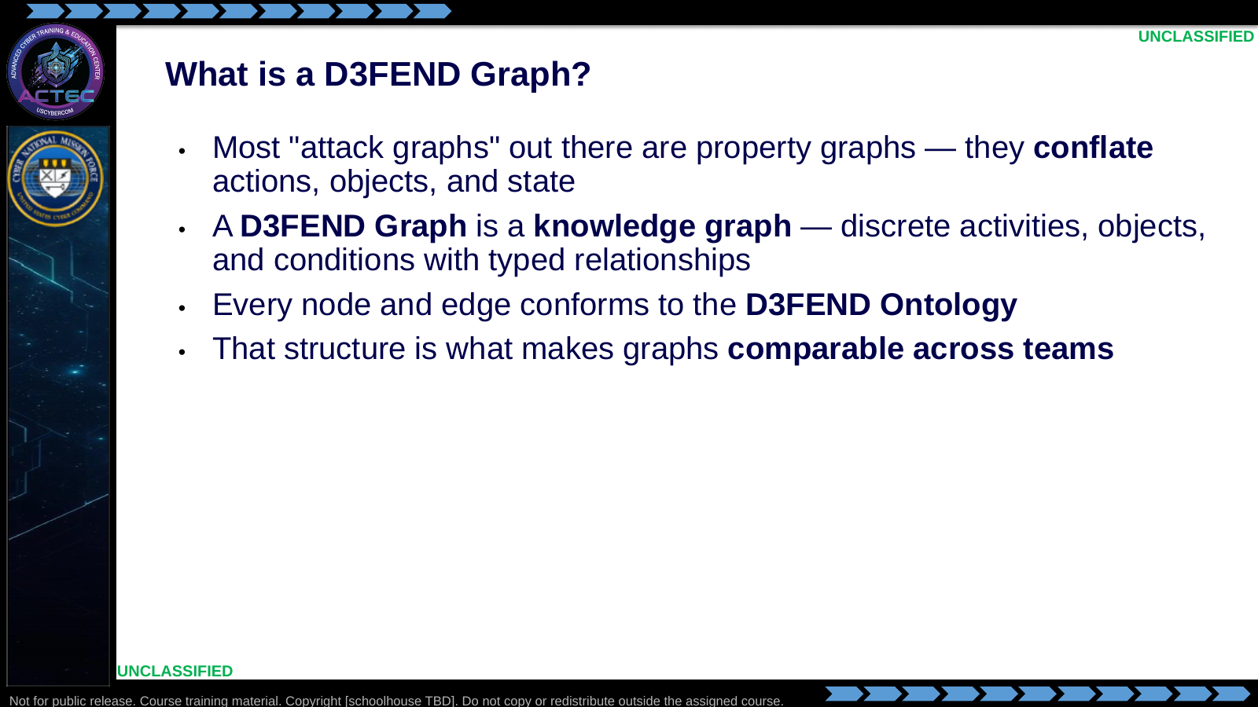  Slide 3: What is a D3FEND Graph?  Duration: 5 min | Say: "The critical distinction — from the MITRE blog, verbatim — is that existing attack graphs conflate actions, objects, and state changes. A D3FEND graph keeps them typed and separate. That is what makes two analysts working the same intrusion on opposite sides of the world produce graphs that can be compared."  Show: Read the definition slowly. Linger on the word "discrete."  Do: Ask: "Why do we care about 'comparable across teams' in DCO-RA?" Drive toward hand-off, deconfliction, and joint operations.  Ask (Q): Why do we care about comparable-across-teams graphs in DCO-RA?  Expected Response (A): Steer toward hand-off, deconfliction, and joint operations. Typed nodes make graphs comparable.
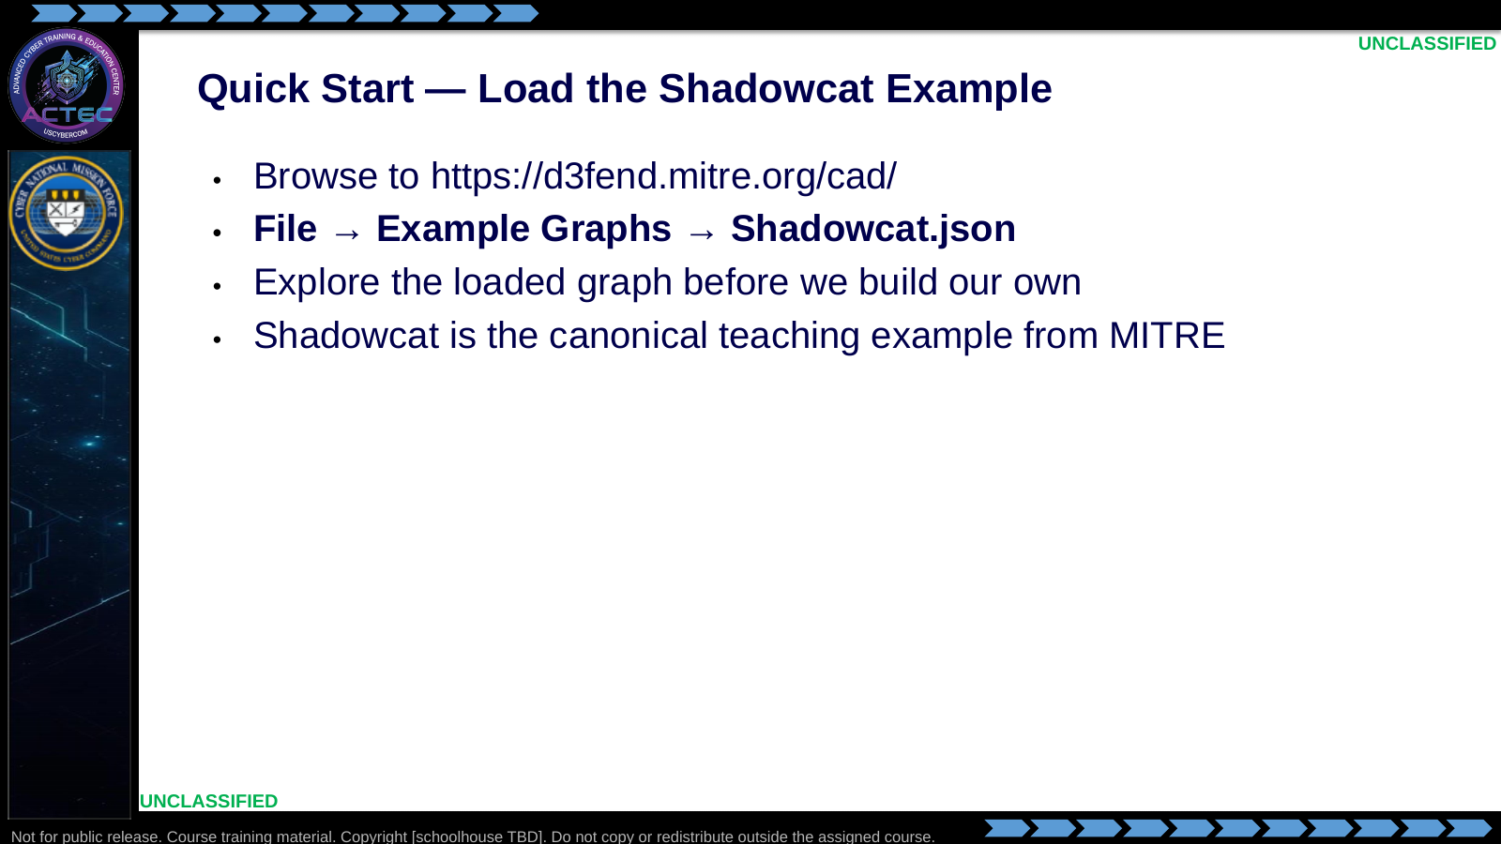  Slide 4: Quick Start — Load the Shadowcat Example  Duration: 3 min | Say: "Everyone open https://d3fend.mitre.org/cad/ on your laptop. Go to File, Example Graphs, and pick Shadowcat.json. When it loads, do not click anything — just look. I want you to see the shape before we talk about the pieces."  Show: Demonstrate the load on the projector. Zoom and pan the graph.  Do: Give the room 3 minutes of silent exploration. Ask: "Before we name anything — what jumps out at you?" Accept 2-3 answers. Nested drill: B01.M29.  Ask (Q): Before we name anything, what jumps out at you on the Shadowcat graph?  Expected Response (A): Facilitation. Accept 2-3 answers. Nested drill: B01.M29.
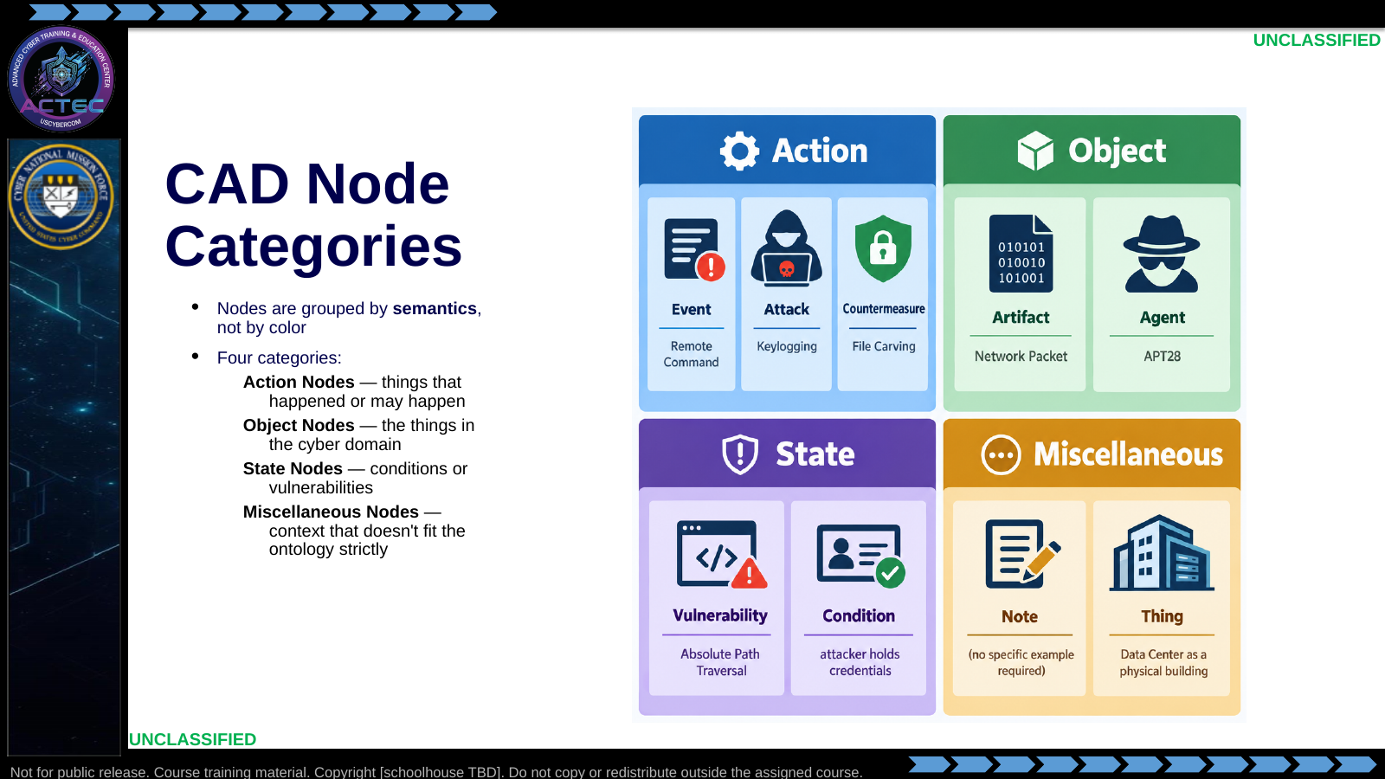  Slide 5: CAD Node Categories  Duration: 5 min | Say: "Four buckets. Action, Object, State, Misc. We are going to walk each one in turn. Whenever you place a node in CAD, you are picking from one of these four buckets first and then refining."  Show: The 2x2 grid; keep it on the side monitor for the next three slides.  Do: Preview: next three slides cover Action, Object, and State in detail.  Ask (Q): When you place a node in CAD, what do you pick first?  Expected Response (A): One of four buckets — Action, Object, State, or Miscellaneous — then refine.
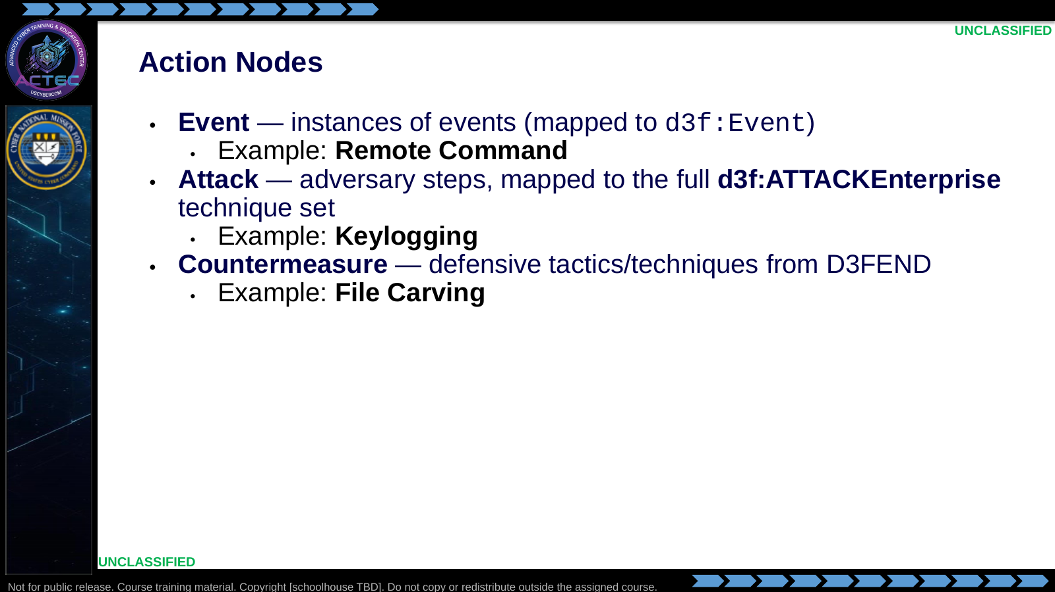  Slide 6: Action Nodes  Duration: 5 min | Say: "Action nodes capture things that happened, things the adversary did, or things we did in response. Events are generic; Attacks are specifically ATT&CK techniques; Countermeasures are specifically D3FEND techniques. The ontology does not let you smear those together."  Show: Drop one of each node type into a new graph on-screen. Open each node's detail panel.  Do: Ask the room: "Pick a technique from your ATT&CK layer in Block 3. Is it an Event or an Attack?" The answer is almost always Attack — reinforce why.  Ask (Q): Pick a technique from your ATT&CK layer. Is it an Event or an Attack?  Expected Response (A): Almost always Attack. Attacks are ATT&CK techniques; Events are generic.
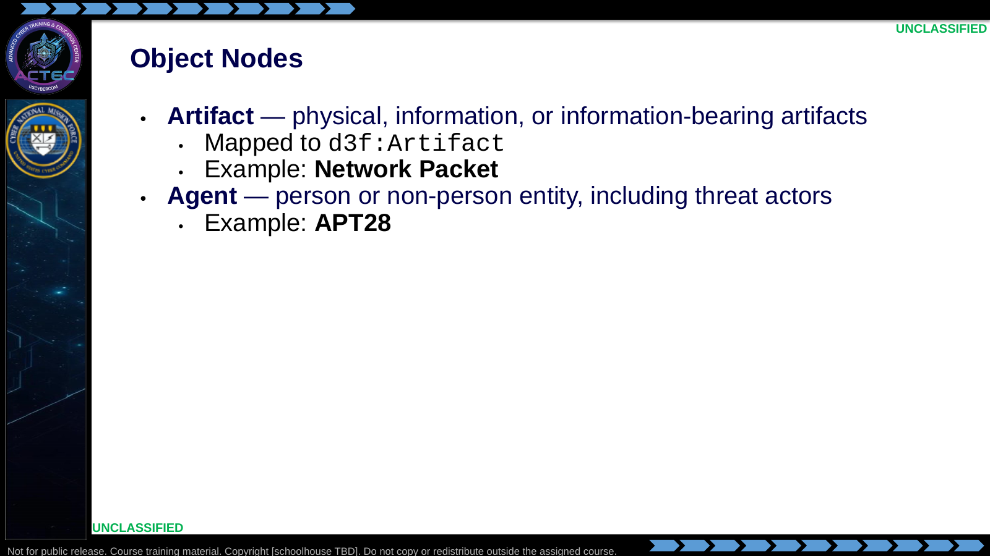  Slide 7: Object Nodes  Duration: 5 min | Say: "Object nodes are the things in the graph. Artifacts are what the action is acting on — a packet, a file, a driver. Agents are who is acting — humans, processes, threat actors. In our course, you are going to place an Agent node for whichever adversary you are graphing."  Show: Place an Artifact node and an Agent node. Show the property panel for each.  Do: Tie back: "The 'Unit' line from your SALUTE in Block 2 — that is the label on your Agent node."  Ask (Q): What from your SALUTE in Block 2 labels the Agent node?  Expected Response (A): The Unit line.
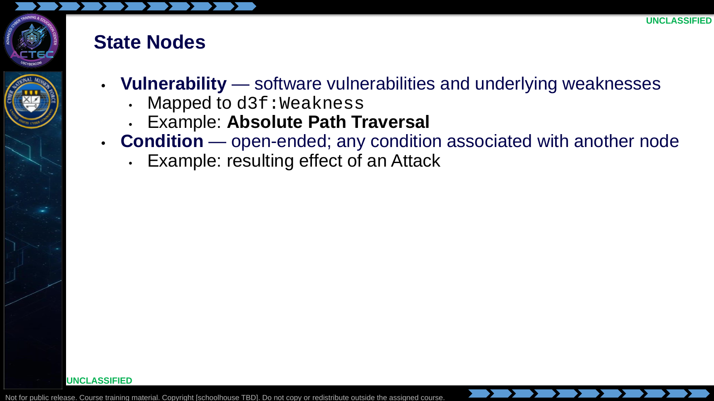  Slide 8: State Nodes  Duration: 5 min | Say: "State nodes capture conditions. Vulnerabilities are the specific weakness class. Conditions are everything else — 'attacker has SYSTEM,' 'service is now unavailable,' 'credentials have been exfiltrated.' Use Condition nodes to capture effects."  Show: Place a Vulnerability node and a Condition node; link them to an Attack node.  Do: Ask: "What Condition would you attach to a successful T1003 credential-dumping attack?" Common answer: "Credentials exfiltrated" or "Attacker holds LSASS-sourced credentials."  Ask (Q): What Condition would you attach to a successful T1003 credential-dumping attack?  Expected Response (A): Credentials exfiltrated, or attacker holds LSASS-sourced credentials.
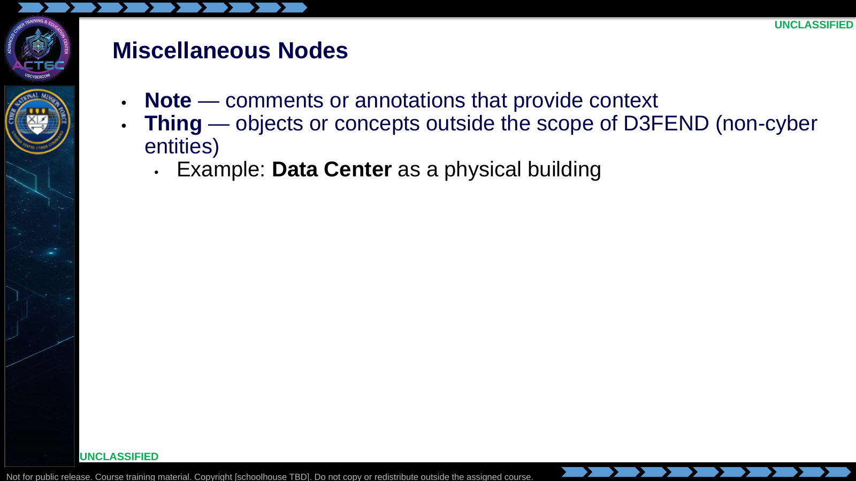  Slide 9: Miscellaneous Nodes  Duration: 5 min | Say: "Misc nodes are your escape hatch. Note is for analyst commentary. Thing is for objects the ontology does not cover — the data center, a specific facility, a physical person. Use them sparingly; if you are using Thing nodes a lot, you are probably missing a real node type."  Show: Place a Note on a node to demonstrate.  Do: Reinforce the "sparingly" rule. Overuse of Thing and Note defeats the purpose of the ontology.  Ask (Q): When should you use Thing or Note?  Expected Response (A): Sparingly. Overuse defeats the ontology. Thing is for objects D3FEND does not cover.
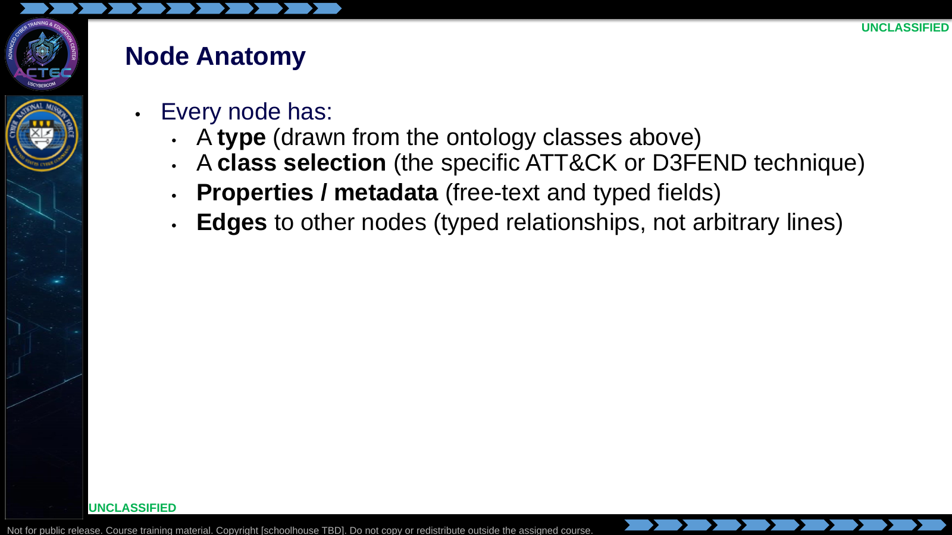  Slide 10: Node Anatomy  Duration: 5 min | Say: "Every node you place has these four pieces. The type puts it in a bucket. The class selection narrows it to a specific ATT&CK or D3FEND technique. Properties carry the evidence. And edges are typed — you do not just draw lines; each edge means something defined in the ontology."  Show: Project ../../references/node_anatomy.jpg full-screen. Walk it top to bottom.  Do: Live on screen, add properties to a node that is already placed. Show the property panel.  Ask (Q): What four pieces does every CAD node have?  Expected Response (A): Type, class selection, properties/metadata, and typed edges.
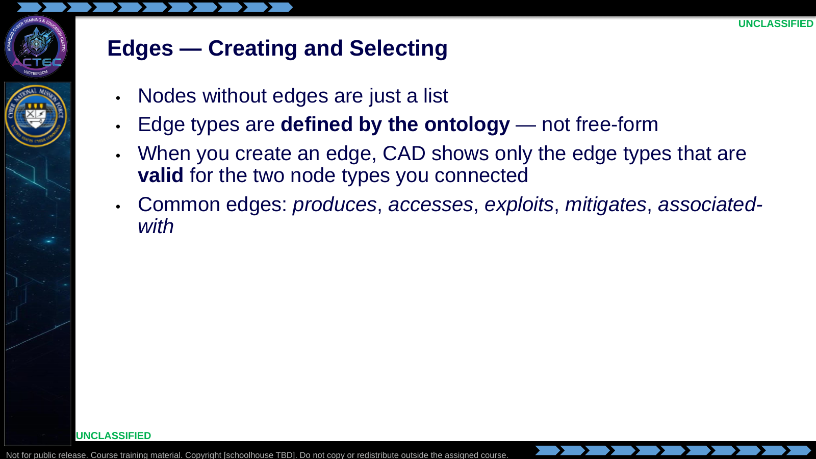  Slide 11: Edges — Creating and Selecting  Duration: 5 min | Say: "This is the part newcomers skip past. Edges are not decorative. Each edge is a typed relationship drawn from the ontology. CAD will only offer you edge types that are valid for the two nodes you are connecting — if you do not see the edge you want, you probably picked the wrong node type."  Show: On-screen, create an edge between an Attack and an Artifact node. Read the available edge types aloud.  Do: Ask the room: "If CAD is not offering you an edge type you need, what does that tell you?" Answer: your node type is wrong.  Ask (Q): If CAD is not offering an edge type you need, what does that tell you?  Expected Response (A): Your node type is wrong.
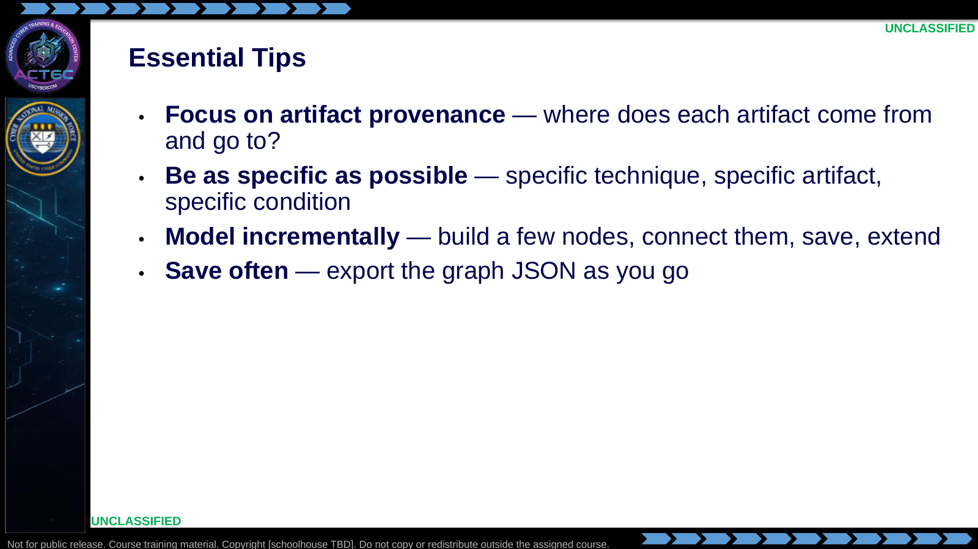  Slide 12: Essential Tips  Duration: 5 min | Say: "Three habits that separate a good CAD graph from a bad one. First — follow artifact provenance; every artifact should have a source. Second — be specific; 'Attack: PowerShell' is worse than 'Attack: T1059.001 PowerShell.' Third — build incrementally; do not try to draw the whole intrusion in one pass."  Show: The three-tip list.  Do: Demonstrate File → Save (exports JSON). Remind the class to save every 5-10 minutes while they work.  Ask (Q): What three habits separate a good CAD graph from a bad one?  Expected Response (A): Artifact provenance, specificity, and incremental modeling. Save and export often.
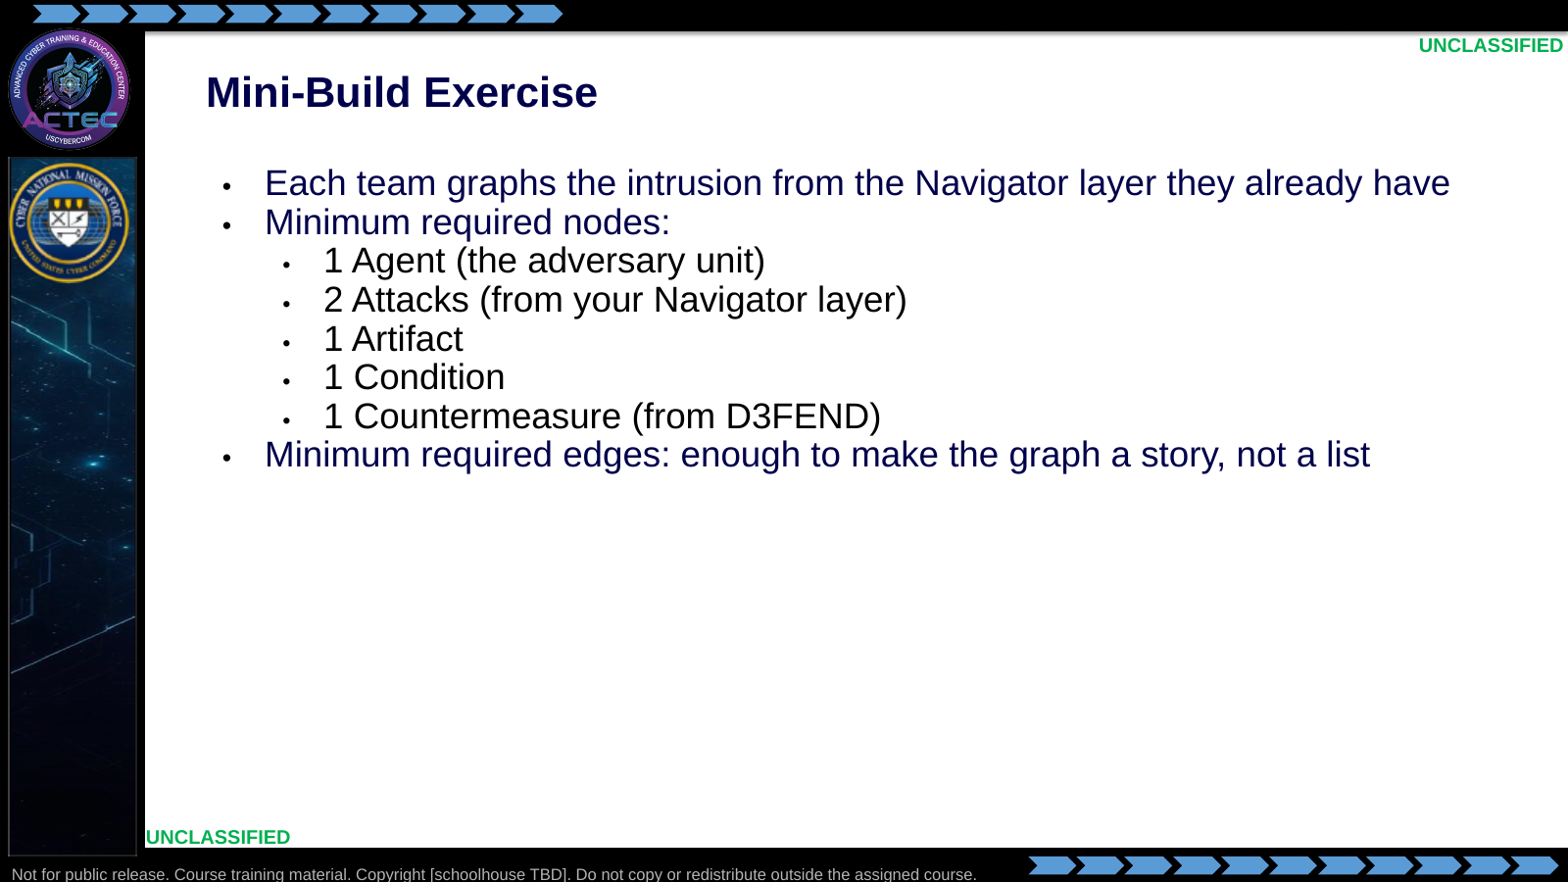  Slide 13: Mini-Build Exercise  Duration: 30 min | Say: "Stay with your current team. You already have the ATT&CK layer. Now turn it into a CAD graph with the minimum node set on this slide. Focus on provenance — every artifact has a source and an effect."  Show: The minimum-node checklist; leave it visible during the exercise.  Do: Timebox: 30 minutes build + 3 minutes per team to back-brief. Export the JSON and retain it for later commander briefing. Nested drill: B01.M30.  Ask (Q): What is the minimum node set for the mini-build?  Expected Response (A): 1 Agent, 2 Attacks, 1 Artifact, 1 Condition, 1 Countermeasure, plus enough edges to make a story. Nested drill: B01.M30.
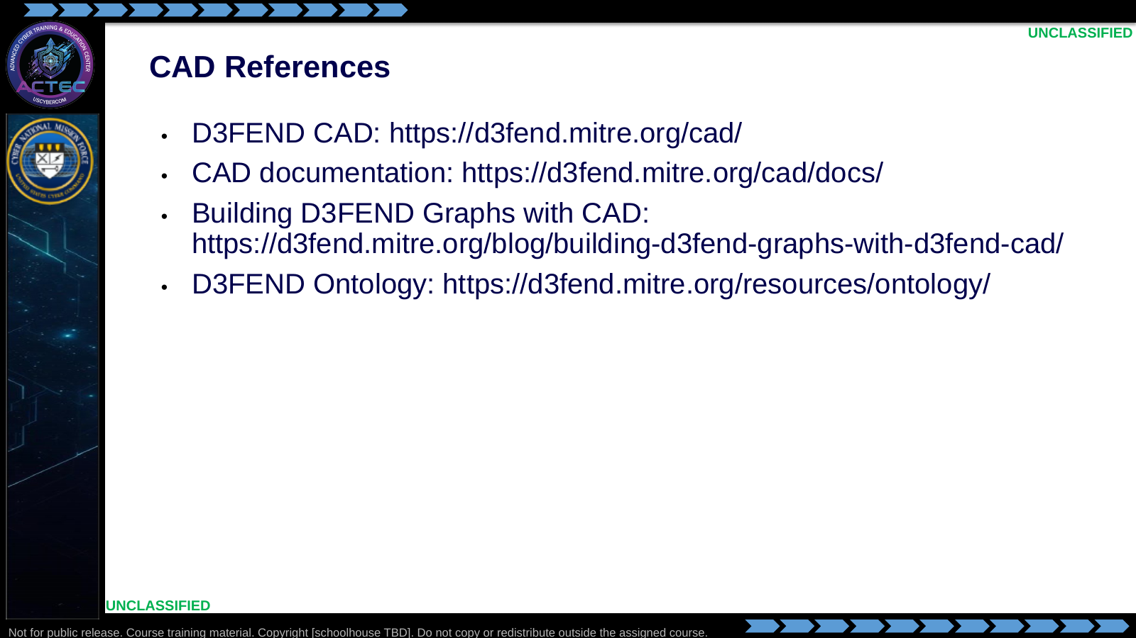  Slide 14: CAD References  Duration: 5 min | Say: "These references are the authoritative starting points when the tool or ontology changes."  Show: Open the CAD documentation and ontology pages.  Do: Have students bookmark the CAD documentation.  Ask (Q): Which reference do you bookmark for when the tool or ontology changes?  Expected Response (A): CAD documentation, and the ontology page as needed.
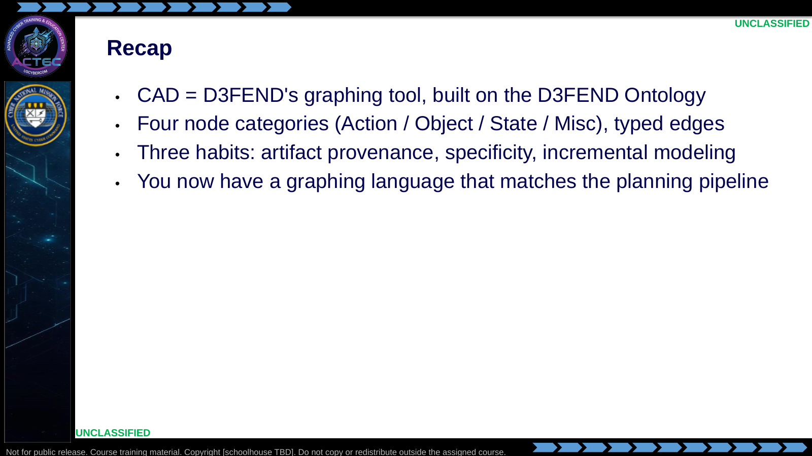  Slide 15: Recap  Duration: 5 min | Say: "You now have the planning pipeline, an ATT&CK layer, paired D3FEND/ENGAGE options, and a graph that preserves the evidence chain."  Show: The evidence flow beside the paired-options sheet.  Do: Confirm exported JSON is saved for later briefing.  Ask (Q): What do you hand off from this lesson?  Expected Response (A): Exported CAD JSON plus the planning-pipeline products. Next: wire frameworks back to tactical tasks.

4.3 Lesson summary
- CAD is the typed communication product for ATT&CK, D3FEND, and ENGAGE analysis already completed.
- A D3FEND graph keeps action, object, and state discrete so graphs are comparable across teams.
- Nested B01.M29 explores Shadowcat; B01.M30 is the mini-build from the Navigator intrusion.
- Retain exported JSON for later commander briefing and tactical-task synthesis.

4.4 Questions and check on learning
- Ask (Q): How does a D3FEND knowledge graph differ from an untyped attack diagram?
- Expected Response (A): It keeps actions, objects, and state typed and separate under the D3FEND ontology, so graphs are comparable across teams.
- Ask (Q): What four node categories do you pick from, and what makes an edge valid?
- Expected Response (A): Action, Object, State, Miscellaneous. CAD only offers ontology-valid edge types for the two node types you connected.
- Ask (Q): What is the minimum mini-build node set, and what three habits keep the graph usable?
- Expected Response (A): 1 Agent, 2 Attacks, 1 Artifact, 1 Condition, 1 Countermeasure, with enough edges to tell a story. Provenance, specificity, incremental modeling.

5. Classification
Classification: UNCLASSIFIED

